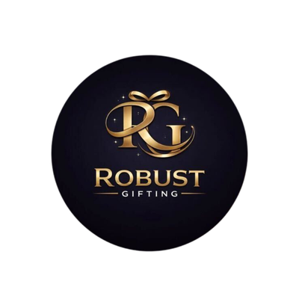
ROBUST GIFTING

Bottles & Drinkware
Catalogue
Stainless Steel · Aluminium · Bamboo · Insulated
Thoughtful gifting. Built to impress.
CURATED COLLECTION • VOLUME 03 • 2026

The Bottles & Drinkware Collection
51 bottles, flasks and mugs — one clear catalogue.
From lightweight single-wall aluminium and stainless-steel everyday bottles to premium 304-grade double-wall vacuum flasks, bamboo-finish insulators and temperature-display mugs — this catalogue brings the full Robust Gifting drinkware range into one place. Capacities run from 450 ml up to 1000 ml. Prices shown are exclusive of 18% GST.
All items available in bulk. Custom branding and packaging on request.
ITEM NO. 01  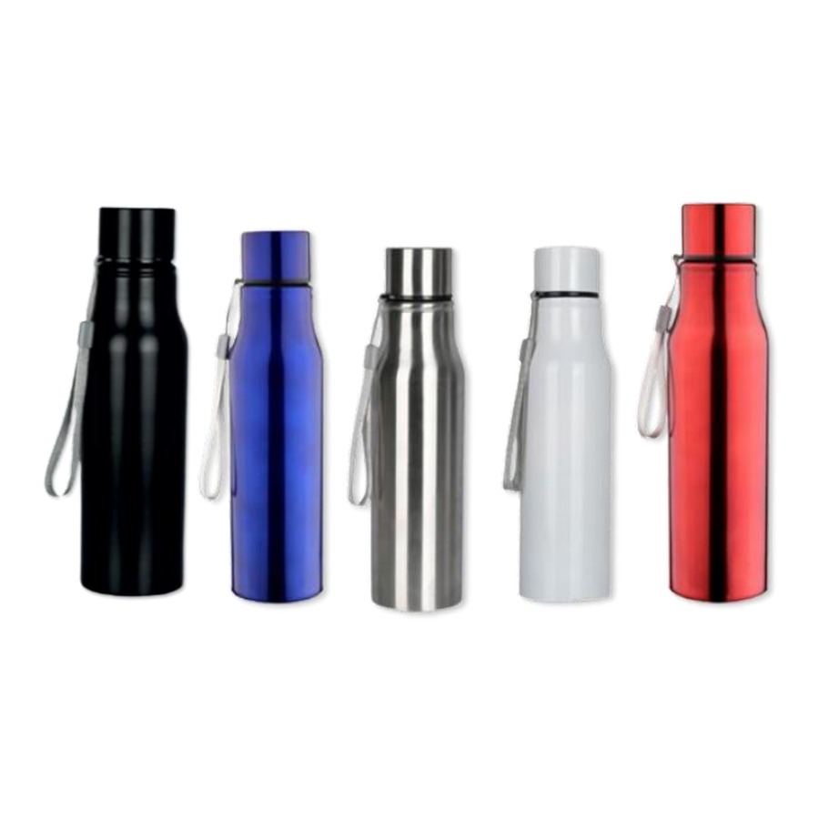  Stainless Steel  Capacity: 750 ml  Stainless-steel bottle.  ₹ 100 + 18% GST |  | ITEM NO. 02  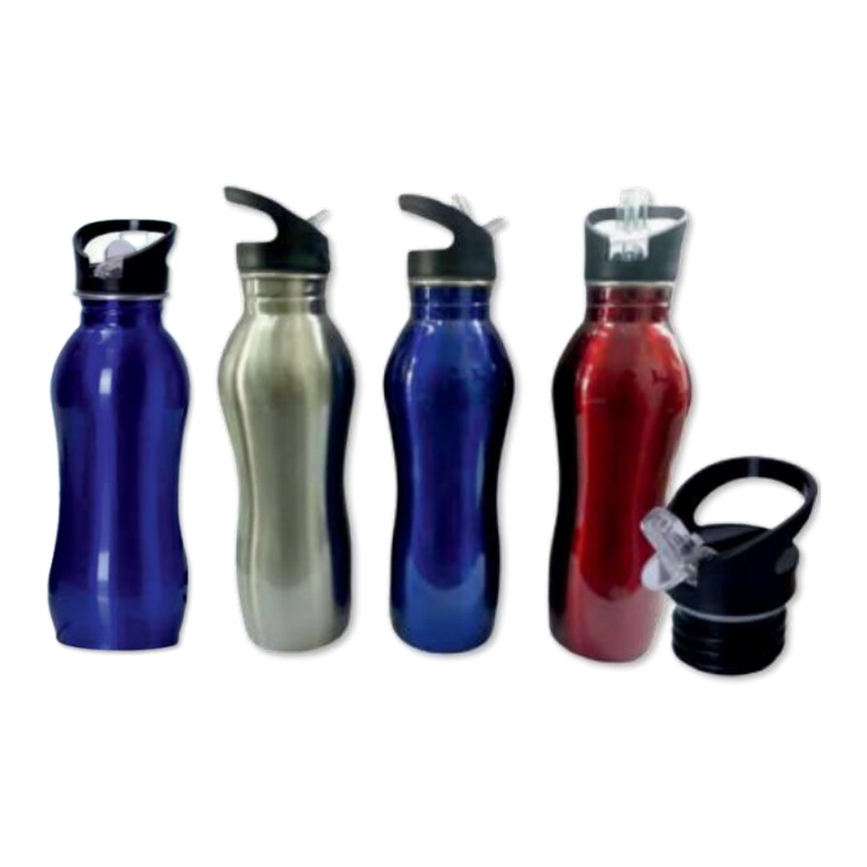  Stainless Steel  Capacity: 750 ml  Stainless-steel bottle.  ₹ 125 + 18% GST
ITEM NO. 03  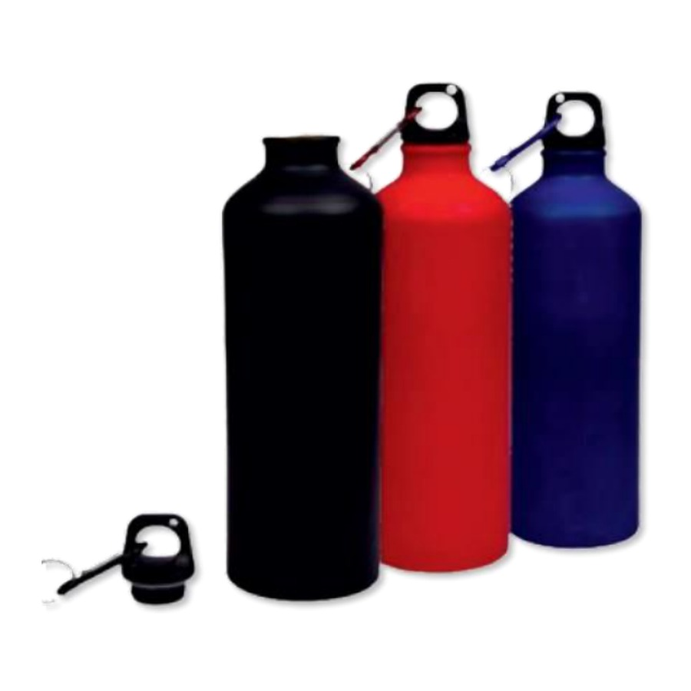  Aluminium  Capacity: 750 ml  Aluminium bottle.  ₹ 90 + 18% GST |  | ITEM NO. 04  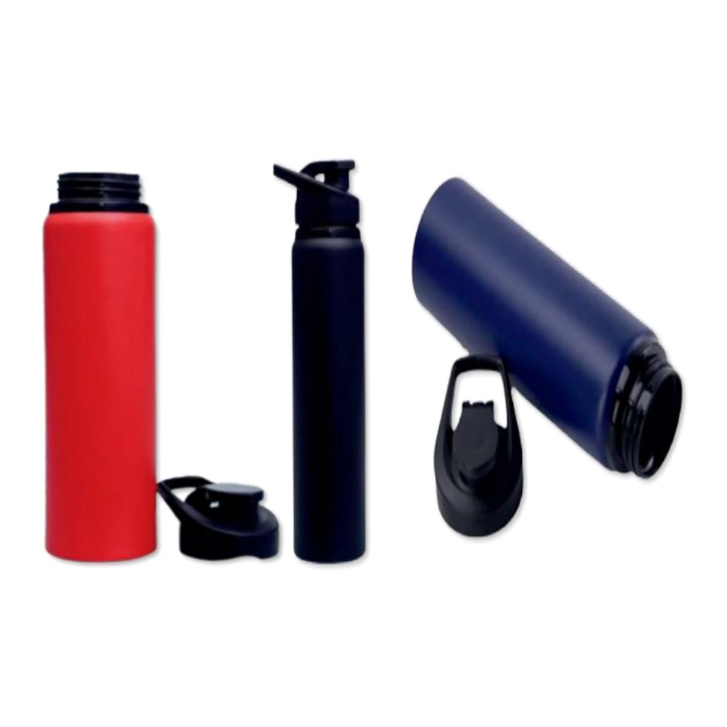  Aluminium Metal Bottle  Capacity: 750 ml  Aluminium bottle.  Price on request
ITEM NO. 05  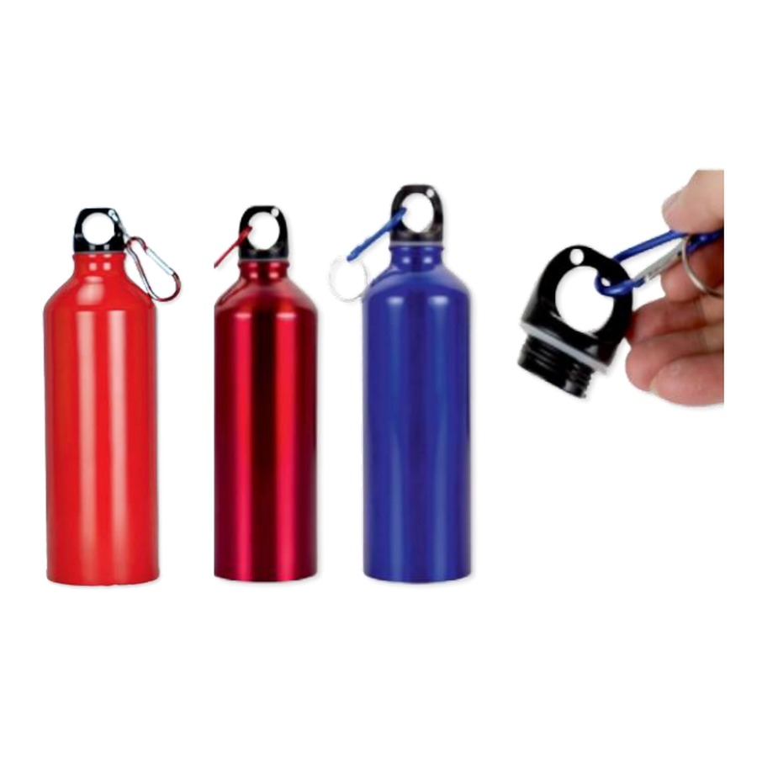  Aluminium Metal Bottle  Capacity: 750 ml  Aluminium bottle.  ₹ 90 + 18% GST |  | ITEM NO. 06  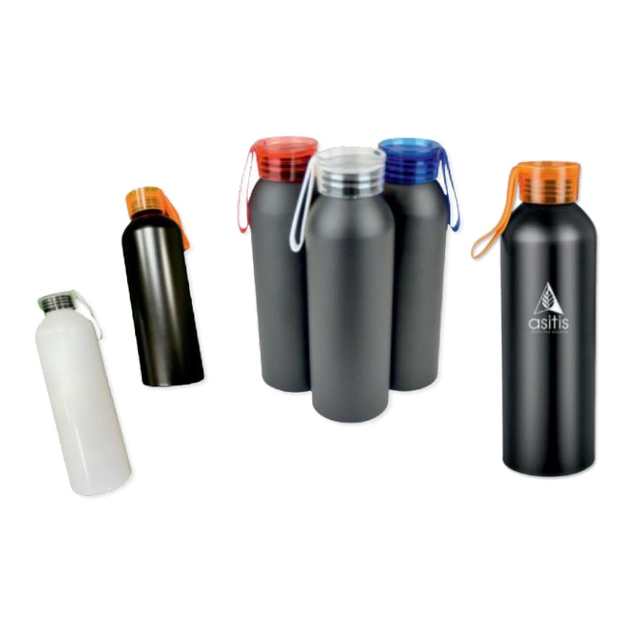  Aluminium Metal Bottle With Silicone Caps  Capacity: 1000 ml  Aluminium bottle.  ₹ 95 + 18% GST
ITEM NO. 07  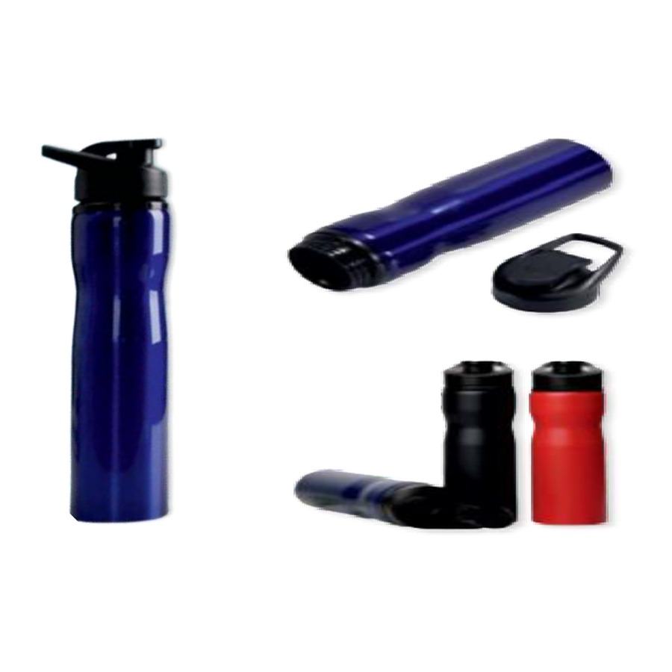  High Grade Stainless Steel Bottle  Capacity: 750 ml  Stainless-steel bottle.  ₹ 110 + 18% GST |  | ITEM NO. 08  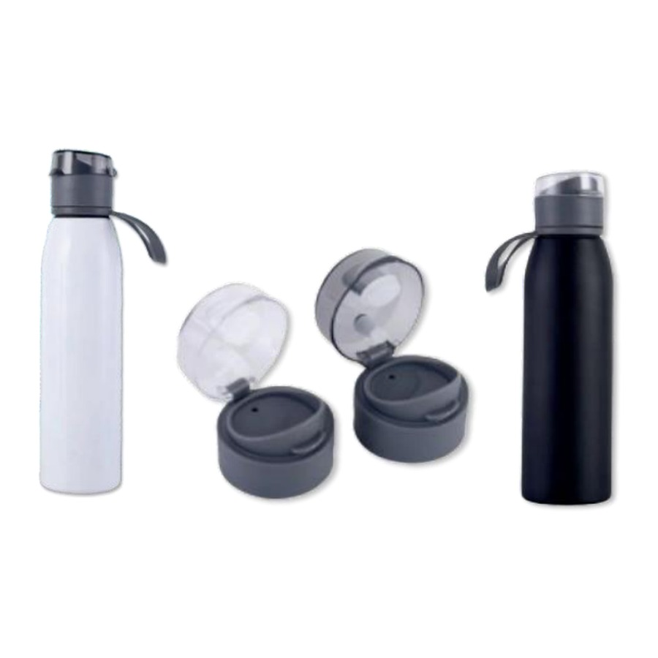  Stainless Steel Bottle With Handle  Capacity: 750 ml  Stainless-steel bottle with handle.  ₹ 120 + 18% GST
ITEM NO. 09  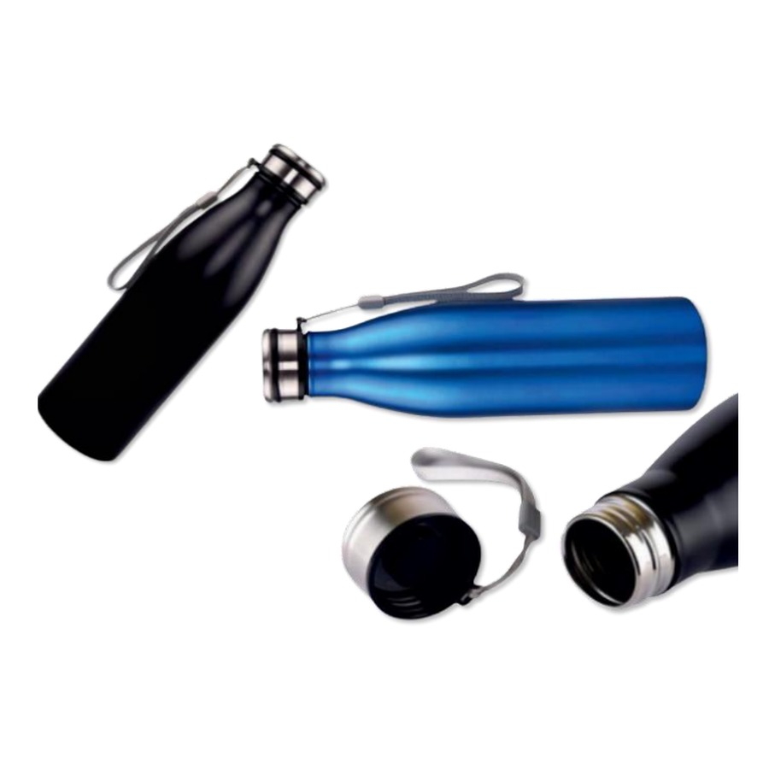  High Quality Stainless Steel With String  Capacity: 750 ml  Stainless-steel bottle with carry strap.  ₹ 125 + 18% GST |  | ITEM NO. 10  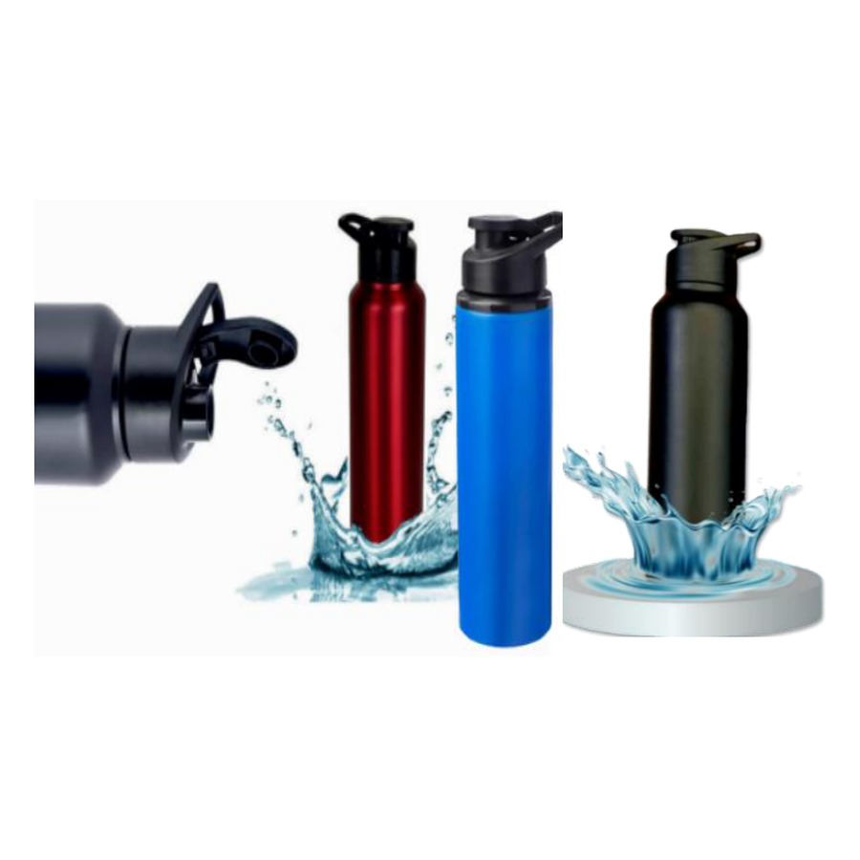  High Quality Stainless Steel  Capacity: 750 ml  Stainless-steel bottle.  ₹ 135 + 18% GST
ITEM NO. 11  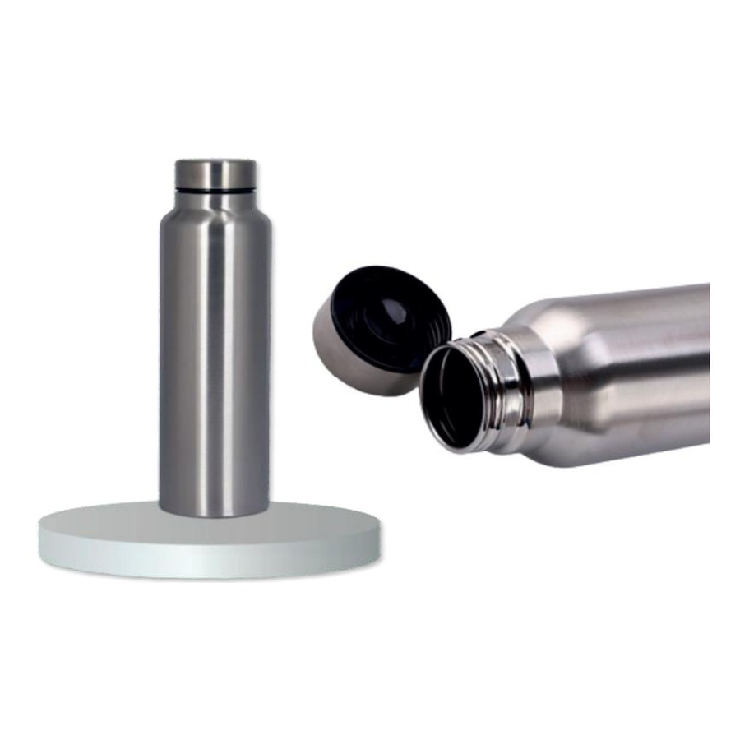  High Grade Steel Water Bottle  Capacity: 1000 ml  Stainless-steel bottle.  ₹ 95 + 18% GST |  | ITEM NO. 12  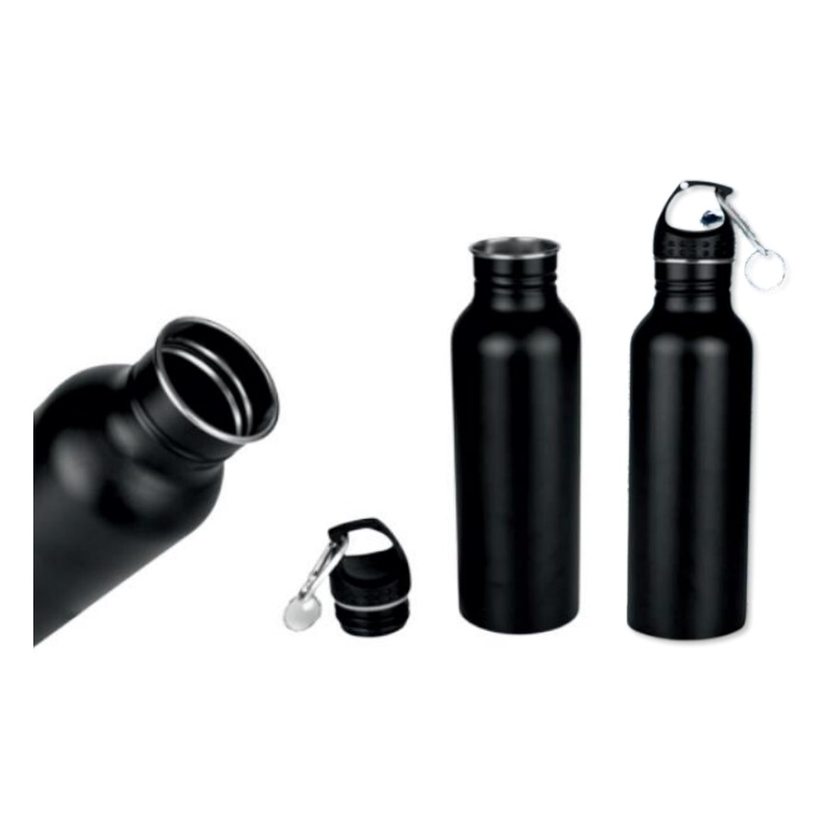  High Quality Stainless Steel  Capacity: 750 ml  Stainless-steel bottle.  ₹ 125 + 18% GST
ITEM NO. 13  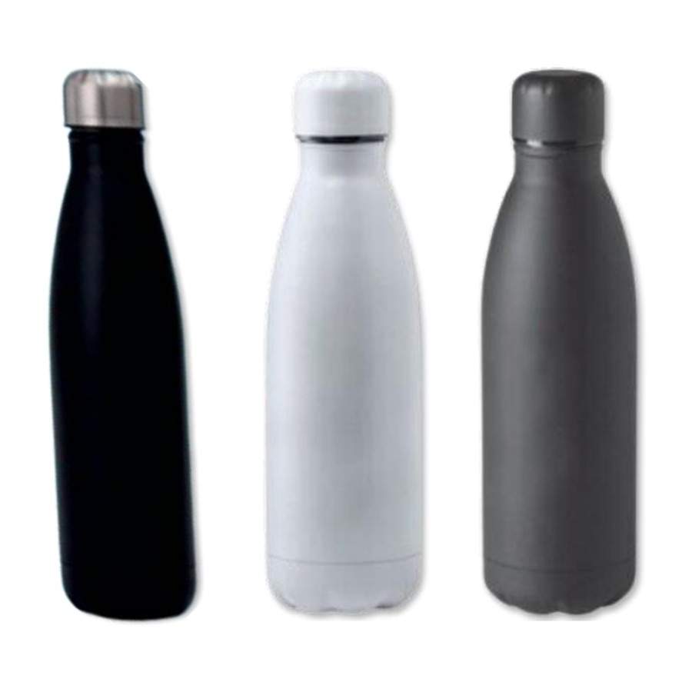  Stainless Steel Bottle With Handle  Capacity: 500 ml  Stainless-steel bottle with handle.  ₹ 200 + 18% GST |  | ITEM NO. 14  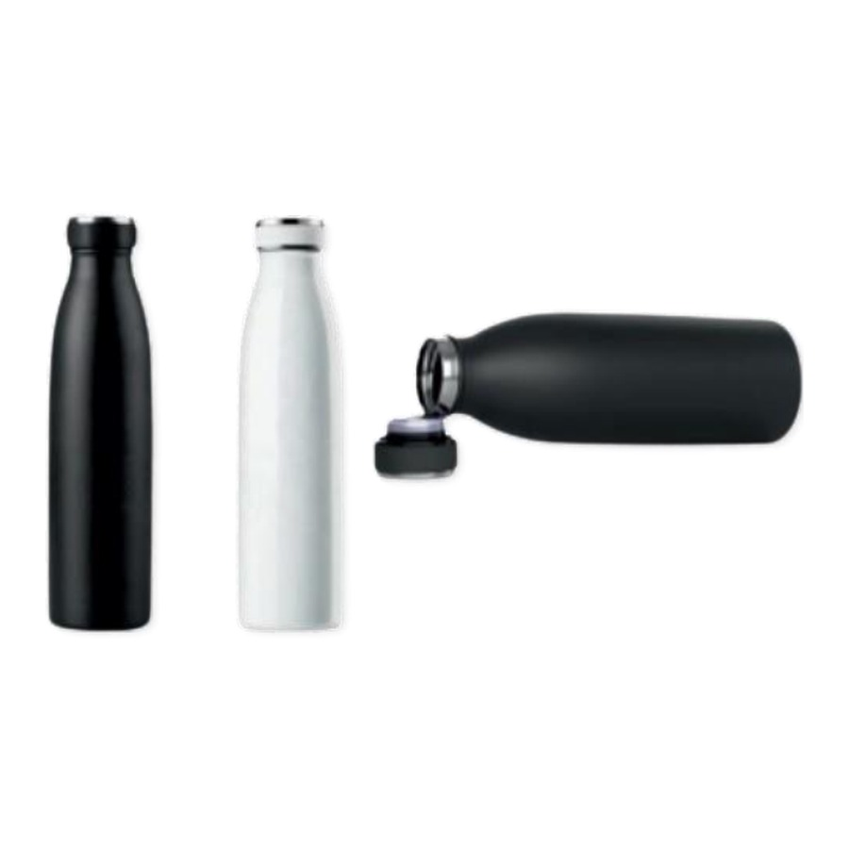  Hot & Cold Vacuum Bottle  Capacity: 750 ml  Insulated vacuum bottle.  ₹ 260 + 18% GST
ITEM NO. 15  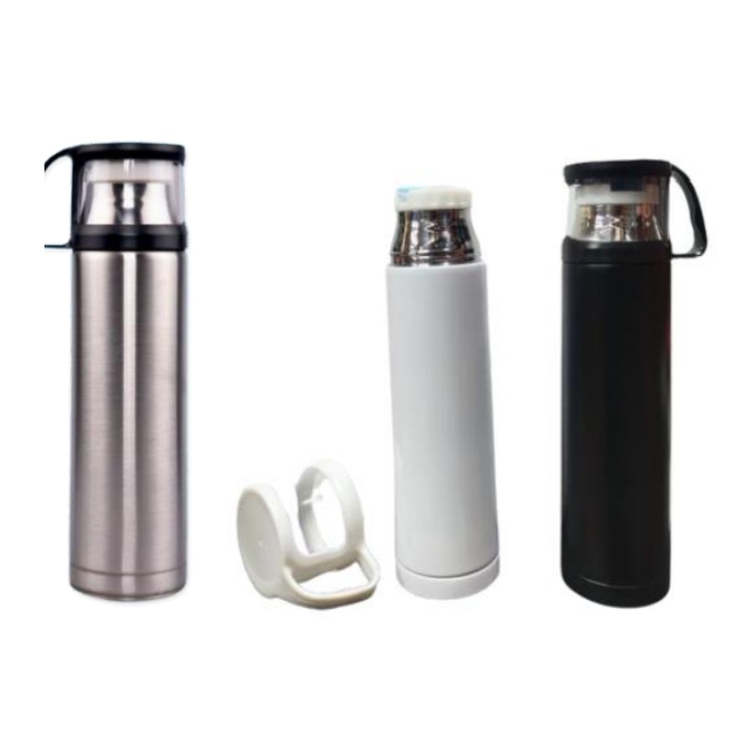  304 Vacuum Insulated Water Bottles  Capacity: 500 ml (approx.)  Insulated vacuum bottle.  ₹ 160 + 18% GST |  | ITEM NO. 16  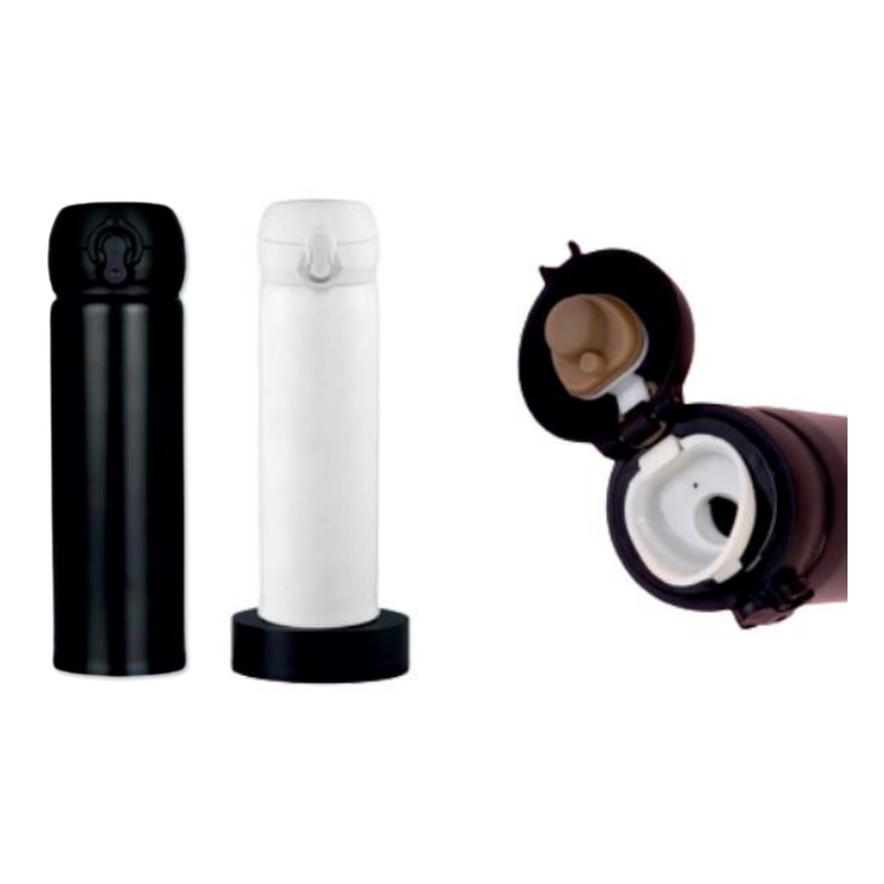  304 Vacuum Insulated Mug With Locking  Capacity: 500 ml (approx.)  Insulated vacuum bottle.  ₹ 145 + 18% GST
ITEM NO. 17  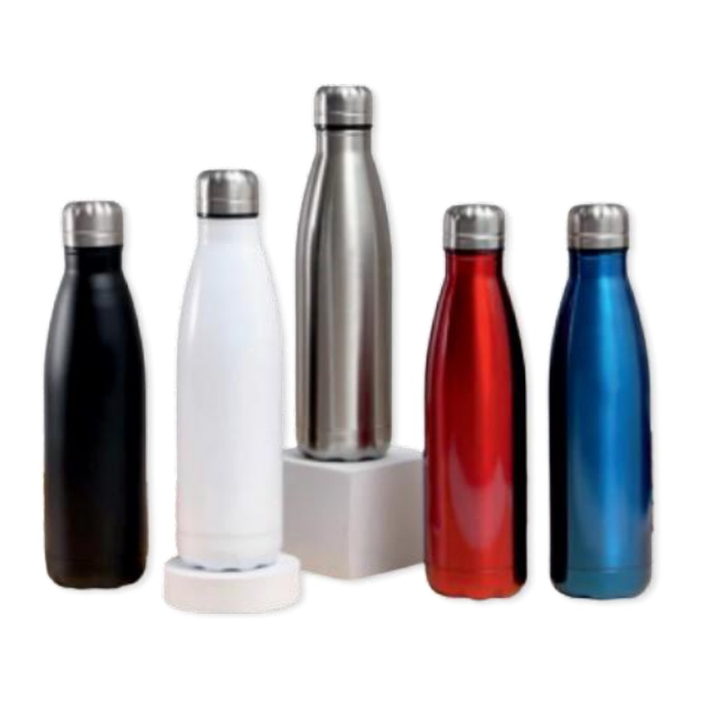  304 Stainless Steel Vacuum Insulated Cup  Capacity: 500 ml (approx.)  Insulated vacuum bottle.  ₹ 200 + 18% GST |  | ITEM NO. 18  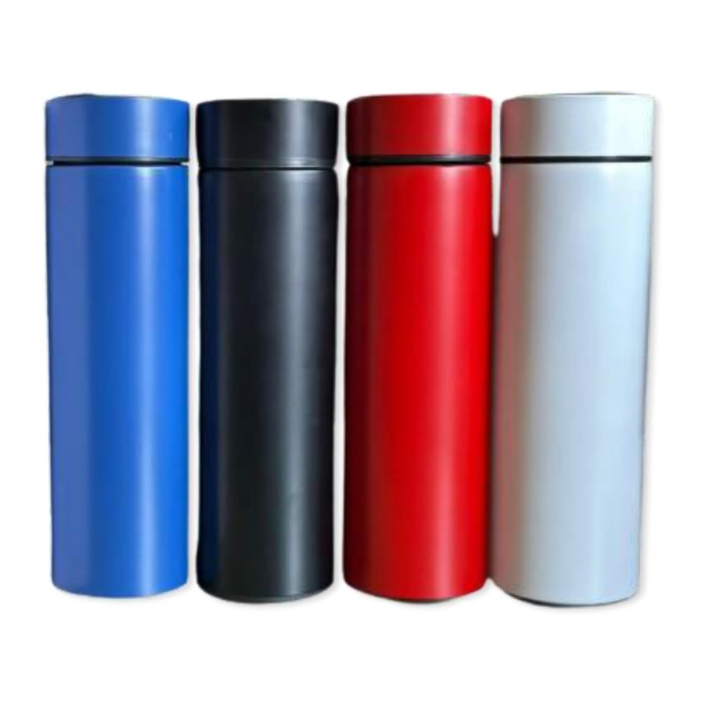  304 Vacuum Temperature Display  Capacity: 500 ml (approx.)  Insulated vacuum bottle with temperature display.  ₹ 125 + 18% GST
ITEM NO. 19  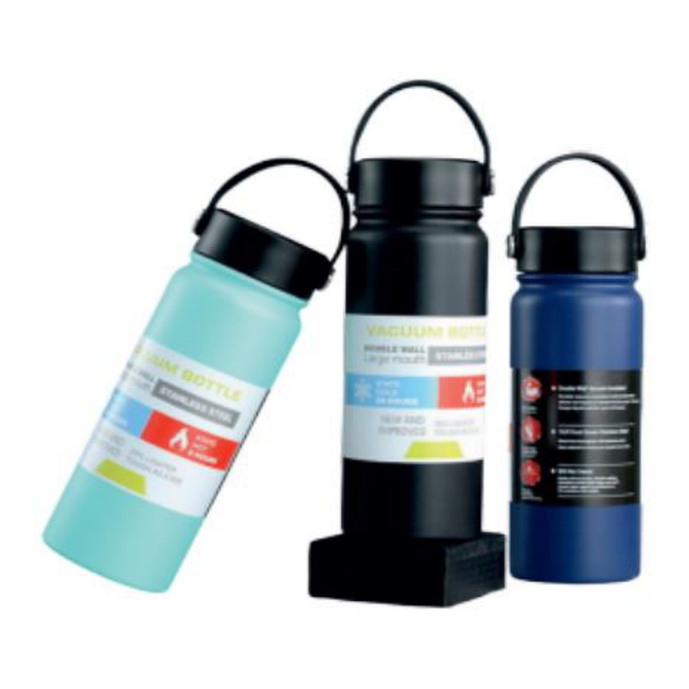  304 Double Wall Insulated Bottle With Strap  Capacity: 800 ml  Insulated vacuum bottle with carry strap.  ₹ 330 + 18% GST |  | ITEM NO. 20  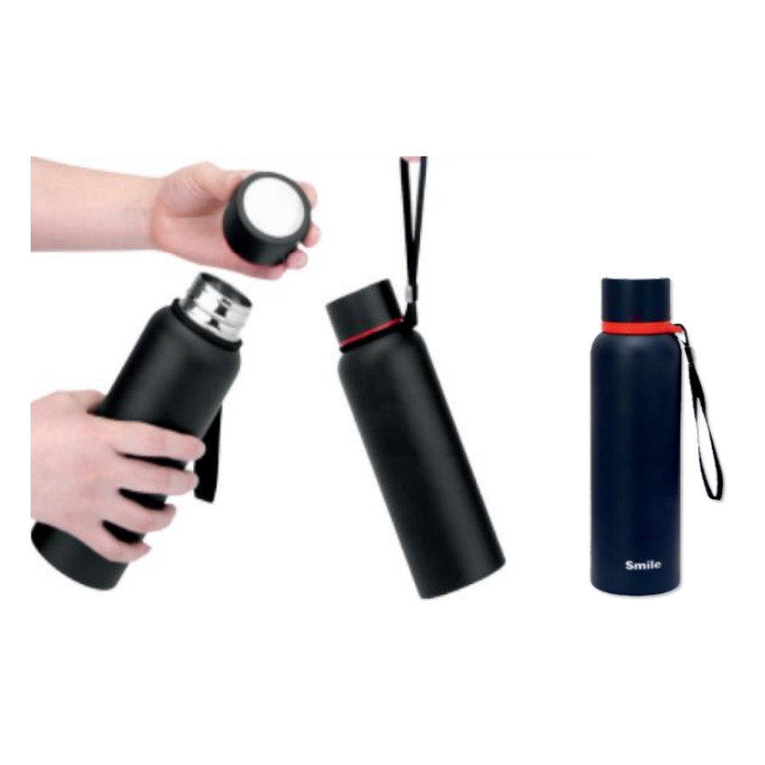  304 Double Wall Insulated Bottle With Strap  Capacity: 500/800 ml  Insulated vacuum bottle with carry strap.  ₹ 325 + 18% GST
ITEM NO. 21  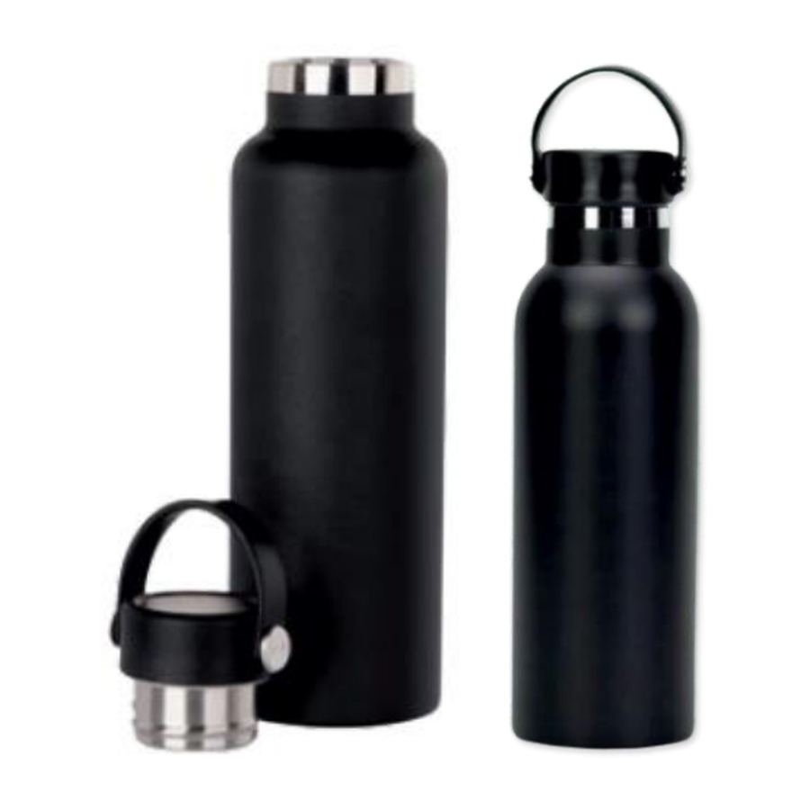  Double Wall Insulated  Capacity: 750 ml  Insulated vacuum bottle.  ₹ 330 + 18% GST |  | ITEM NO. 22  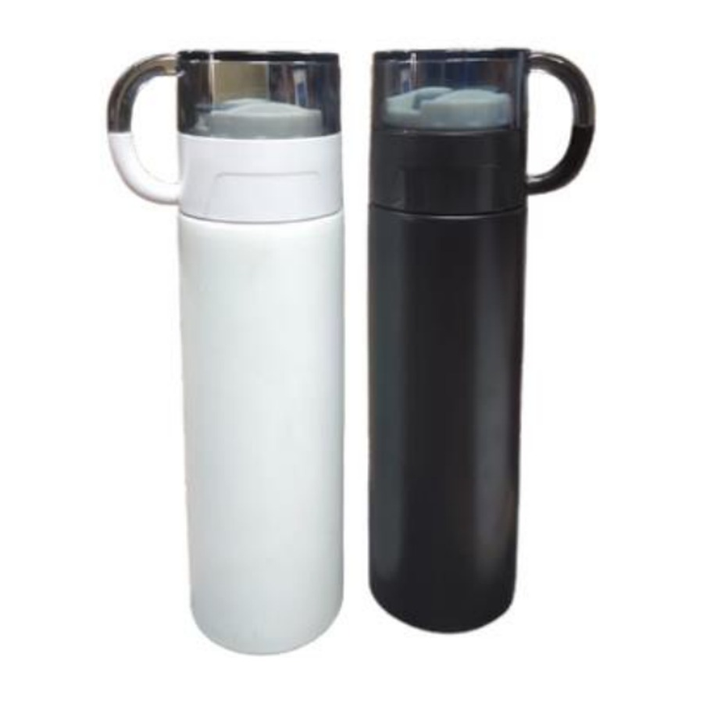  Eco Friendly Vacuum Insulated Flask With Tea Cup  Capacity: 500 ml  Insulated vacuum bottle with tea cup.  ₹ 220 + 18% GST
ITEM NO. 23  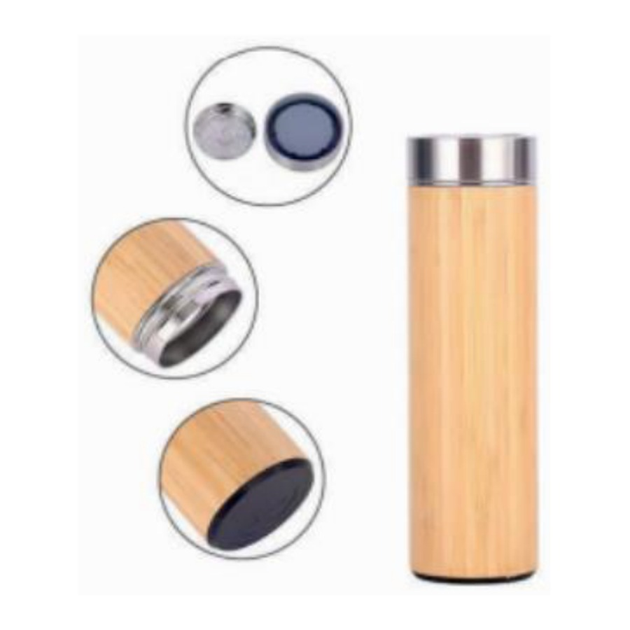  High Quality Bamboo Thermos Vacuum Flask 304 Steel Grade  Capacity: 450 ml  Insulated vacuum bottle.  ₹ 240 + 18% GST |  | ITEM NO. 24  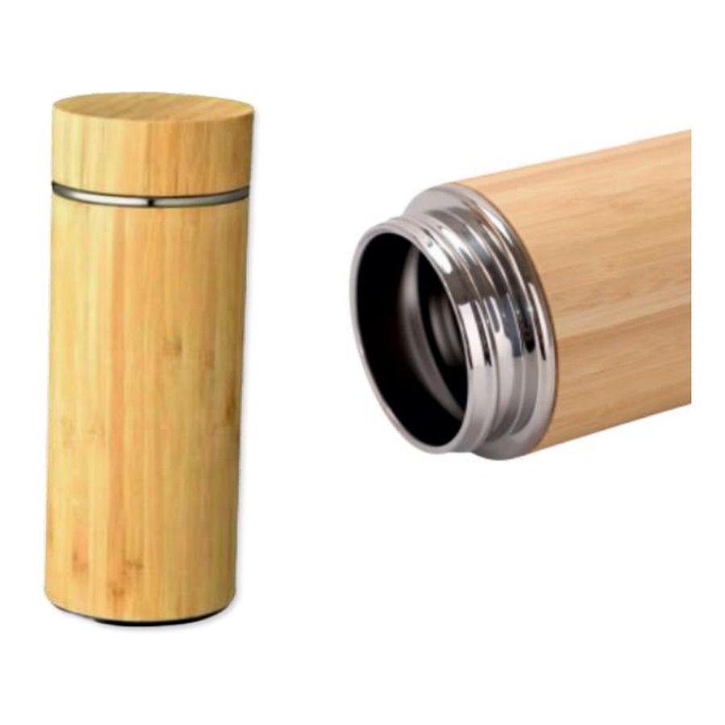  304 Double Wall Insulated Thermos Bamboo Bottle  Capacity: 500 ml  Insulated vacuum bottle.  ₹ 275 + 18% GST
ITEM NO. 25  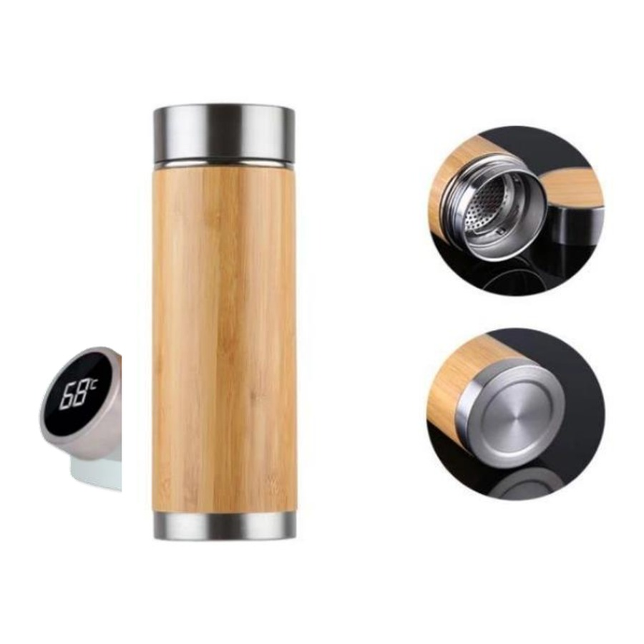  Bamboo Vacuum Insulated Bottle  Capacity: 450 ml  Insulated vacuum bottle.  ₹ 240 + 18% GST |  | ITEM NO. 26  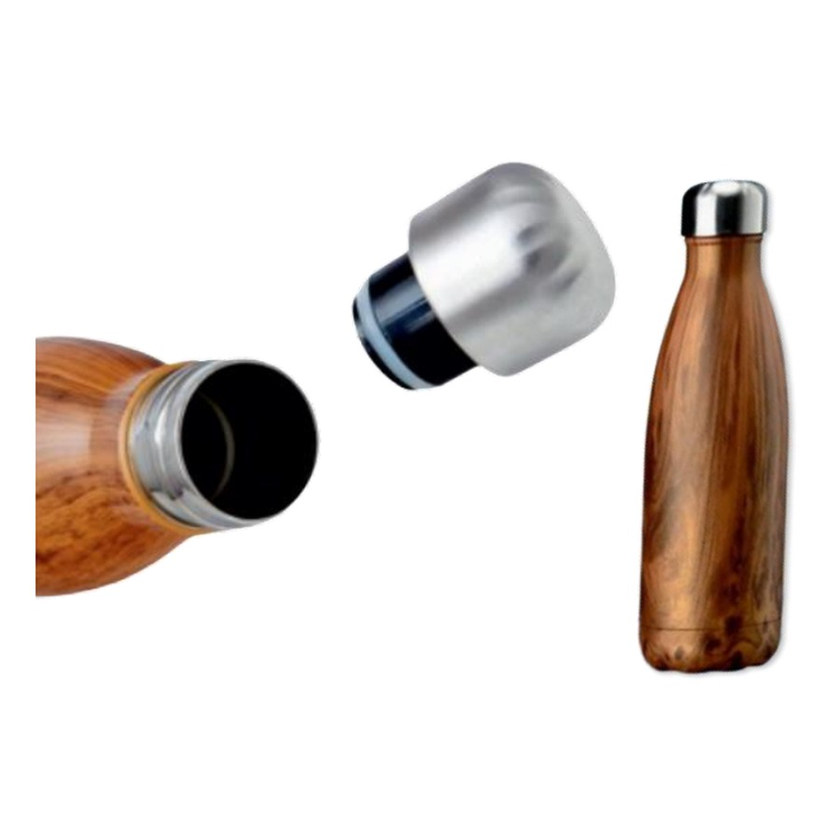  304 Double Wall Insulated Thermos Bottle  Capacity: 500 ml  Insulated vacuum bottle.  ₹ 285 + 18% GST
ITEM NO. 27  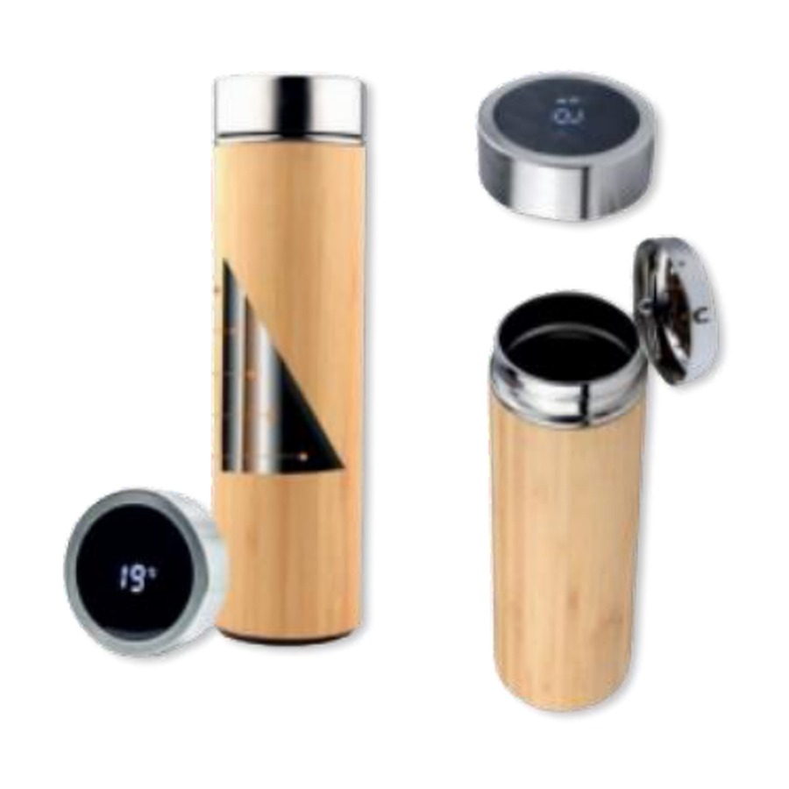  304 Double Wall Insulated Thermos Bamboo Bottle With Temperature Display  Capacity: 500 ml  Insulated vacuum bottle with temperature display.  ₹ 275 + 18% GST |  | ITEM NO. 28  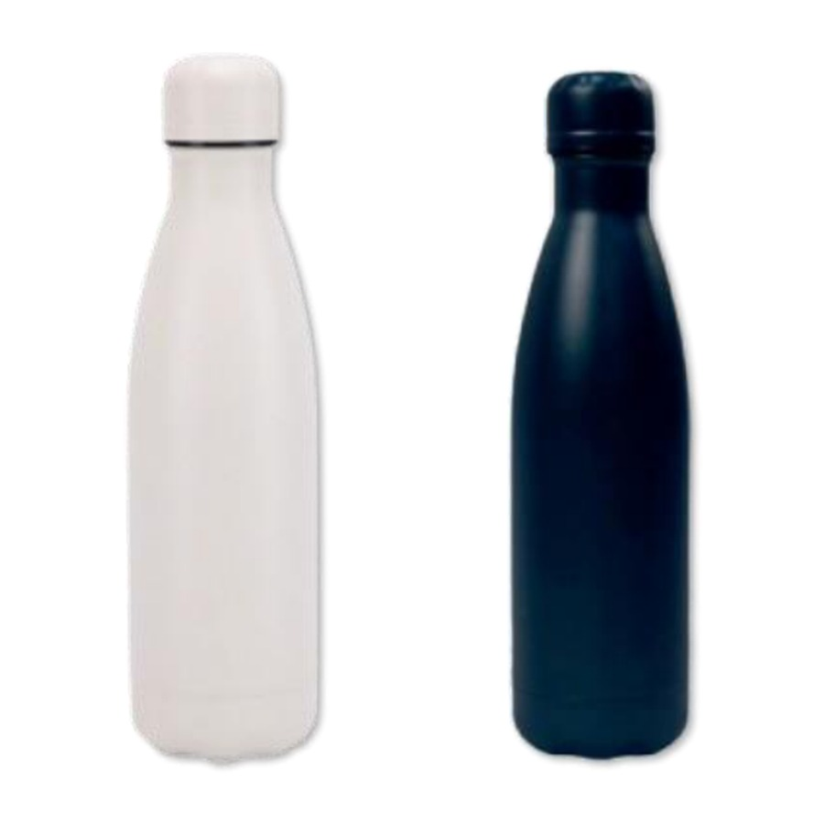  304 Double Wall Insulated Thermos Bottle  Capacity: 500 ml  Insulated vacuum bottle.  ₹ 200 + 18% GST
ITEM NO. 29  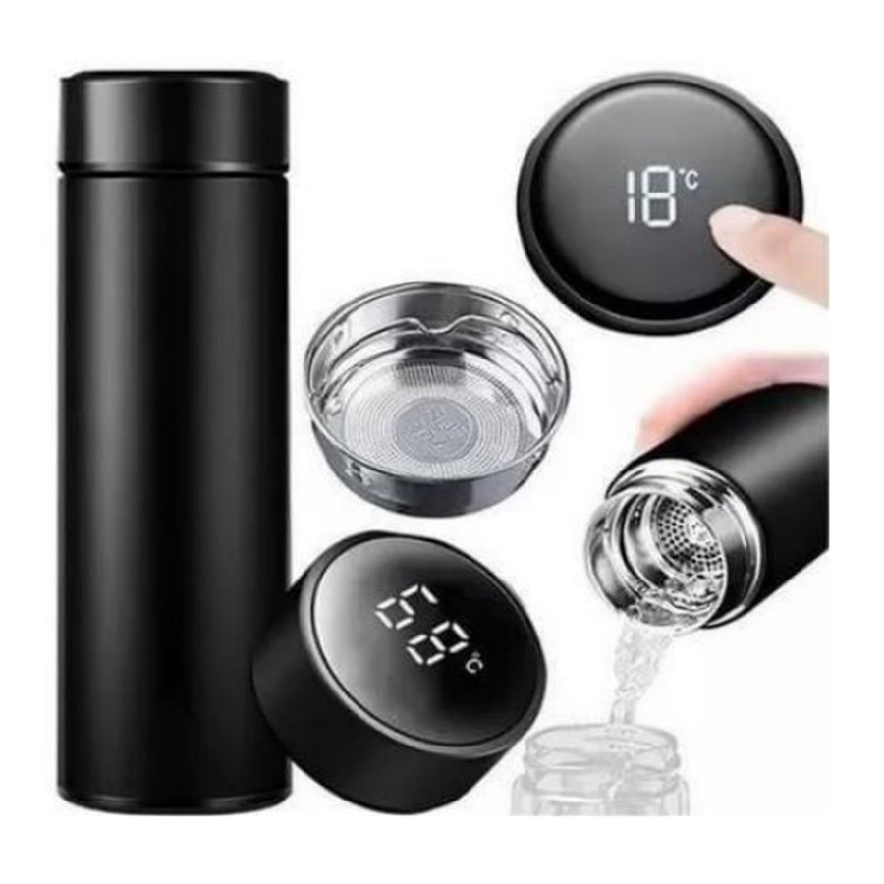  Temperature Bottle  Capacity: 500 ml  Premium water bottle.  ₹ 125 + 18% GST |  | ITEM NO. 30  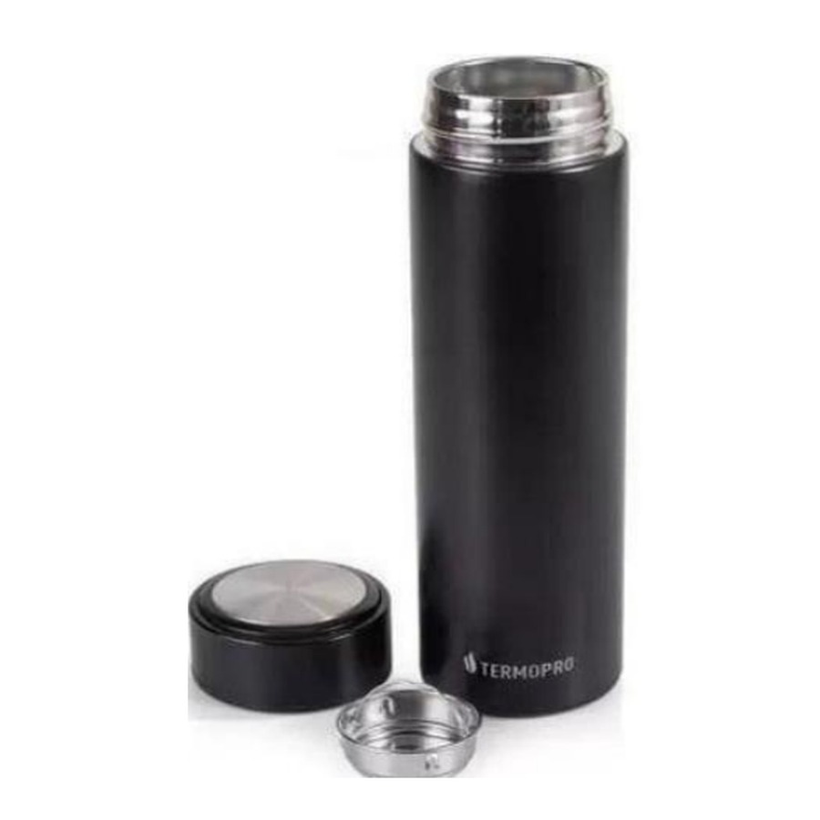  Non Display Temperature Bottle  Capacity: 500 ml  Premium water bottle with temperature display.  ₹ 125 + 18% GST
ITEM NO. 31  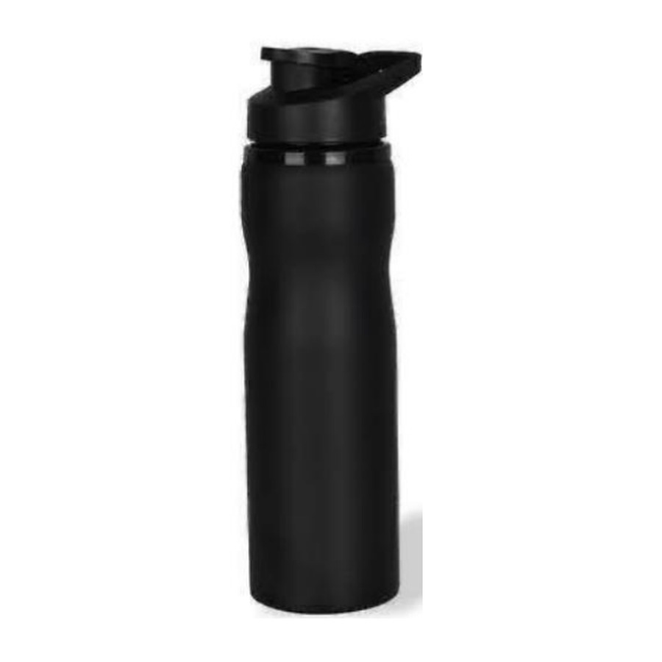  Stainless Steel Sipper Bottle  Capacity: 750 ml  Sipper-style bottle.  ₹ 120 + 18% GST |  | ITEM NO. 32  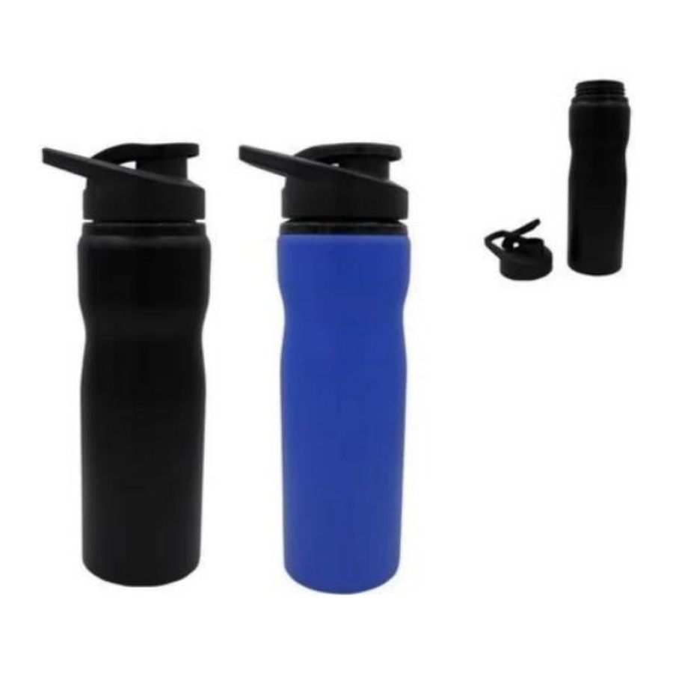  Aluminium Sipper Bottle  Capacity: 750 ml  Aluminium bottle.  ₹ 120 + 18% GST
ITEM NO. 33  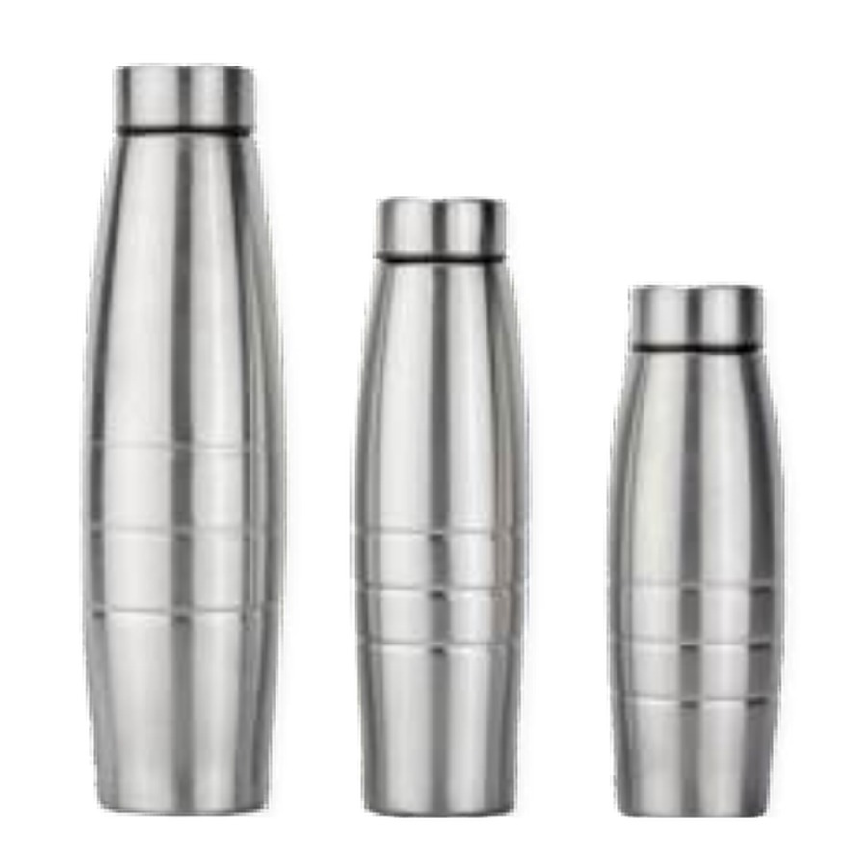  Stainless Steel Single Wall  Capacity: 1000 ml  Lightweight single-wall bottle.  ₹ 95 + 18% GST |  | ITEM NO. 34  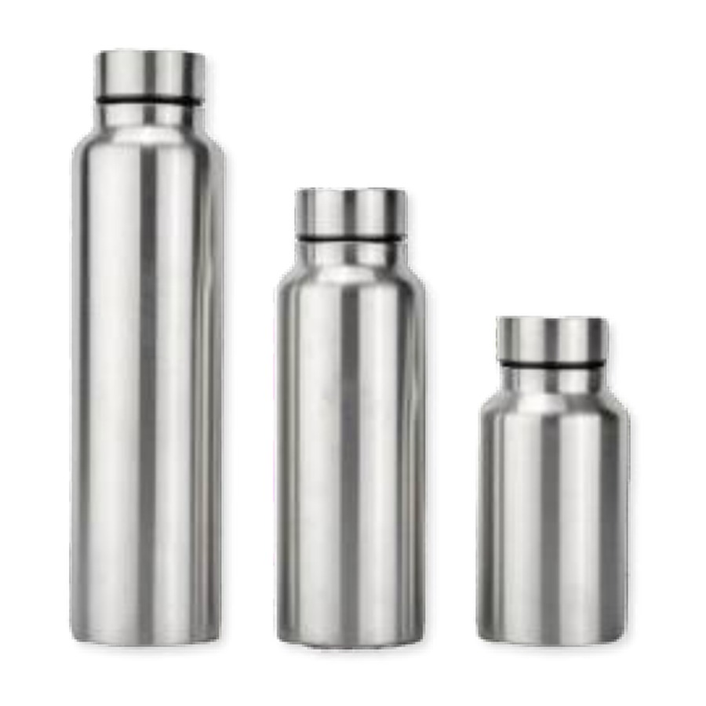  Stainless Steel Single Wall  Capacity: 1000,750,500 ml  Lightweight single-wall bottle.  ₹ 95 + 18% GST
ITEM NO. 35  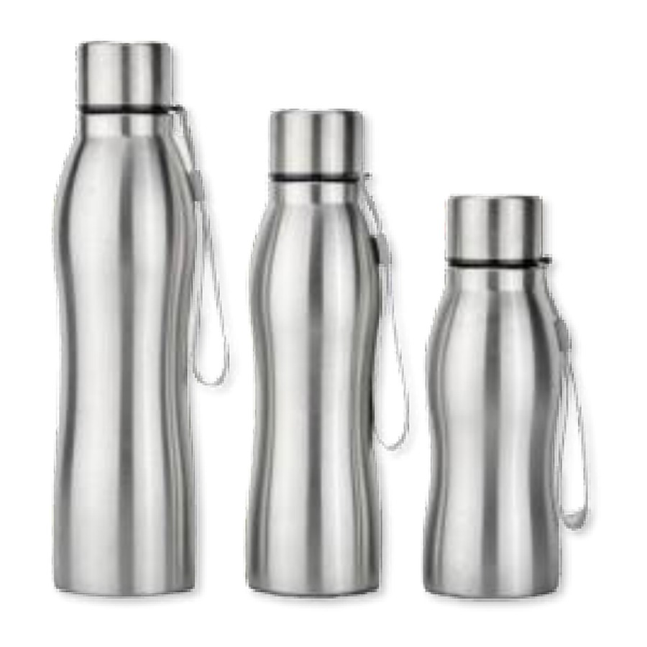  Stainless Steel Single Wall  Capacity: 1000,750,500 ml  Lightweight single-wall bottle.  ₹ 95 + 18% GST |  | ITEM NO. 36  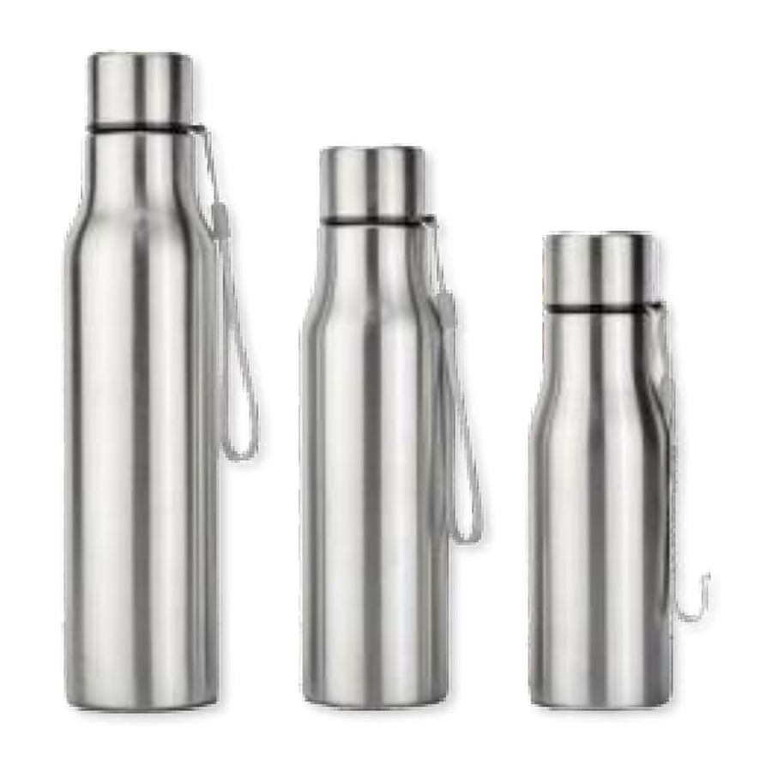  Stainless Steel Single Wall  Capacity: 1000 ml  Lightweight single-wall bottle.  ₹ 95 + 18% GST
ITEM NO. 37  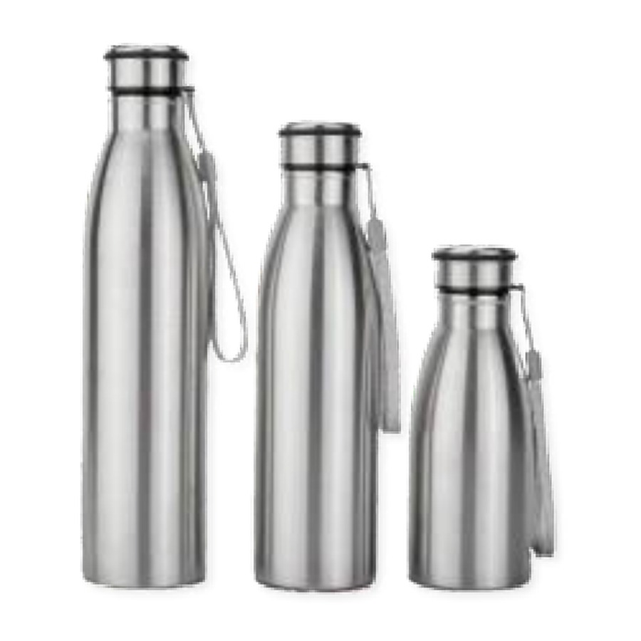  Single Wall Bottle  Capacity: 500,750,1000 ml  Lightweight single-wall bottle.  ₹ 95 + 18% GST |  | ITEM NO. 38  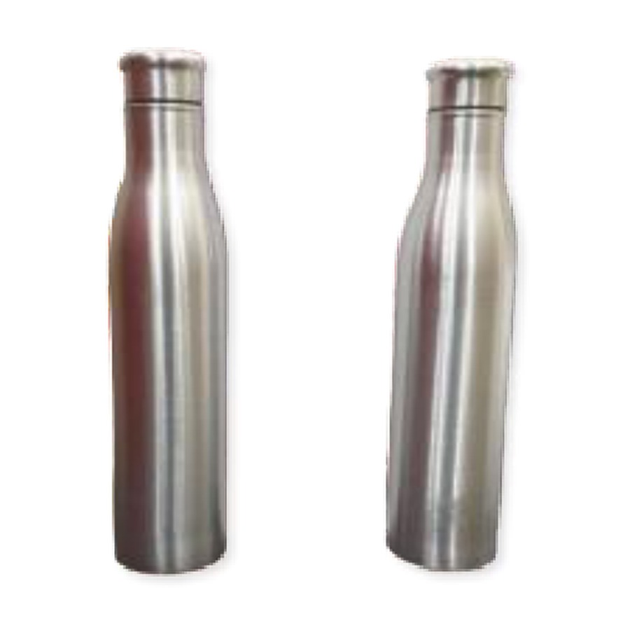  Single Wall Bottle  Capacity: 1000 ml  Lightweight single-wall bottle.  ₹ 95 + 18% GST
ITEM NO. 39  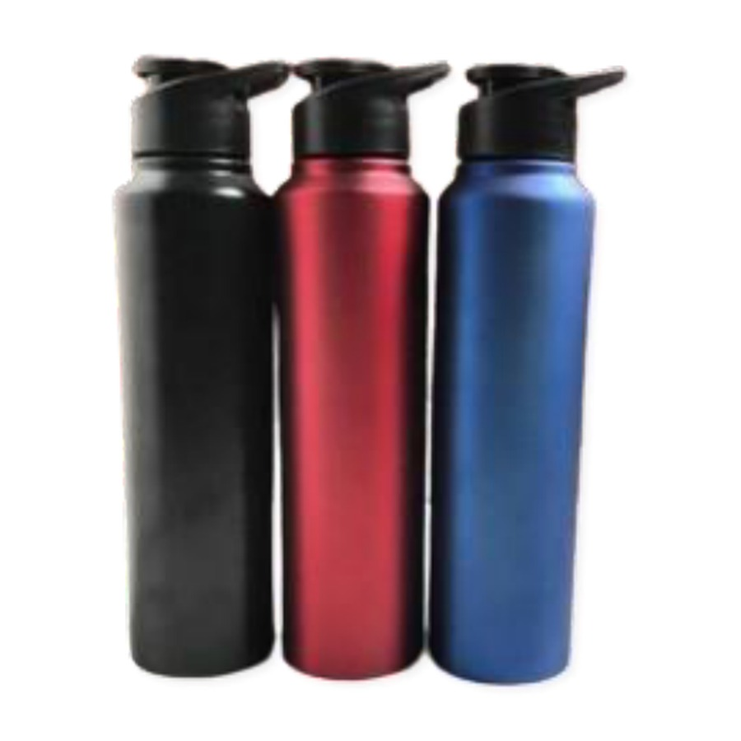  Single Wall Bottle  Capacity: 1000 ml  Lightweight single-wall bottle.  ₹ 135 + 18% GST |  | ITEM NO. 40  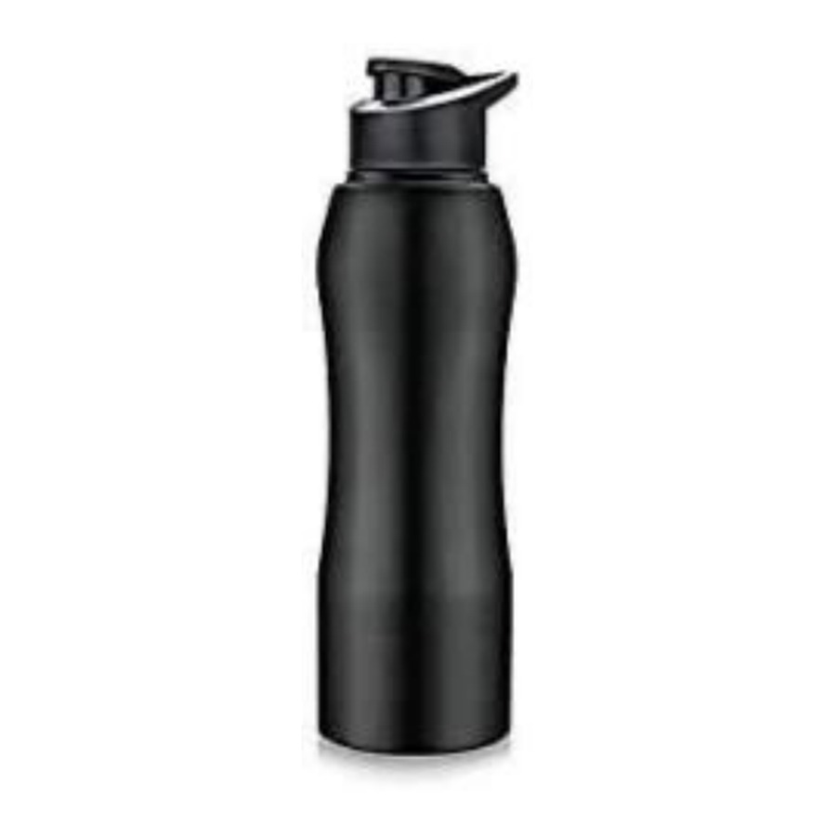  Single Wall Bottle  Capacity: 1000 ml / 750 ml  Lightweight single-wall bottle.  ₹ 135 + 18% GST
ITEM NO. 41  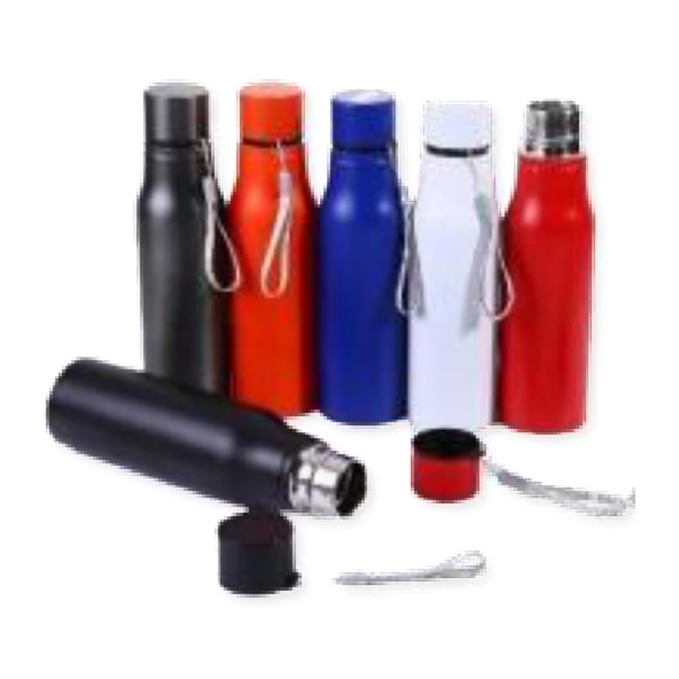  Single Wall Bottle  Capacity: 750 ml  Lightweight single-wall bottle.  ₹ 100 + 18% GST |  | ITEM NO. 42  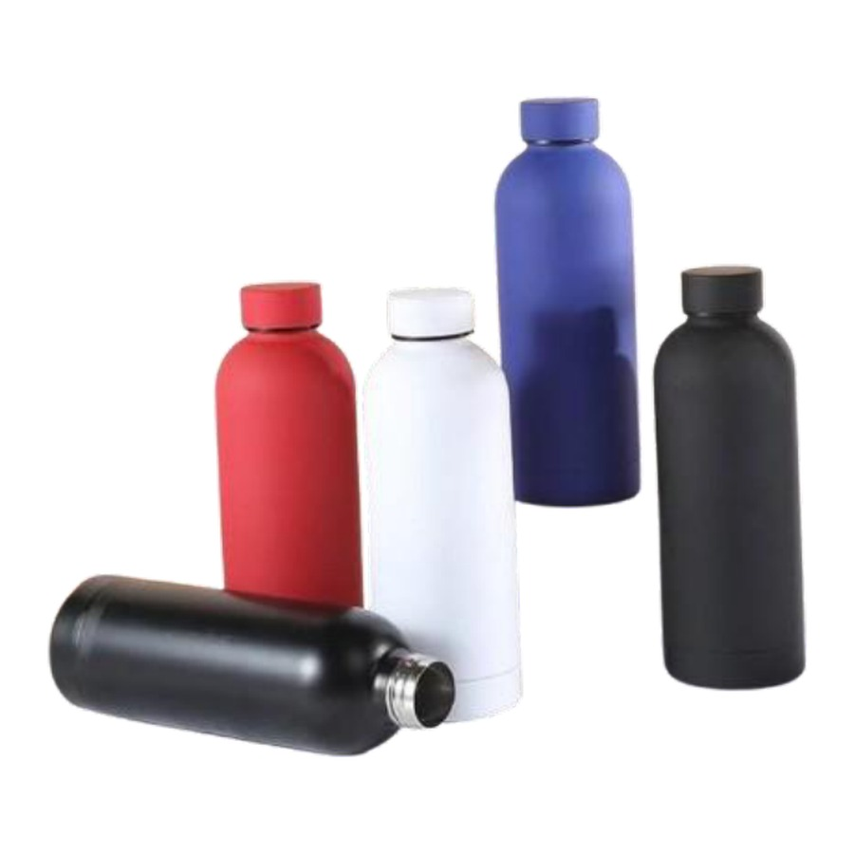  Single Wall Bottle  Capacity: 750 ml  Lightweight single-wall bottle.  ₹ 240 + 18% GST
ITEM NO. 43  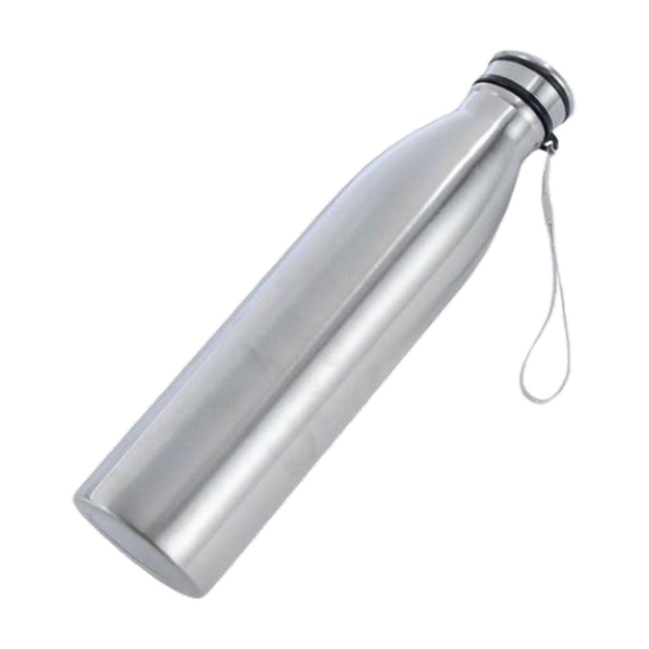  Single Wall Bottle  Capacity: 750 ml  Lightweight single-wall bottle.  ₹ 95 + 18% GST |  | ITEM NO. 44  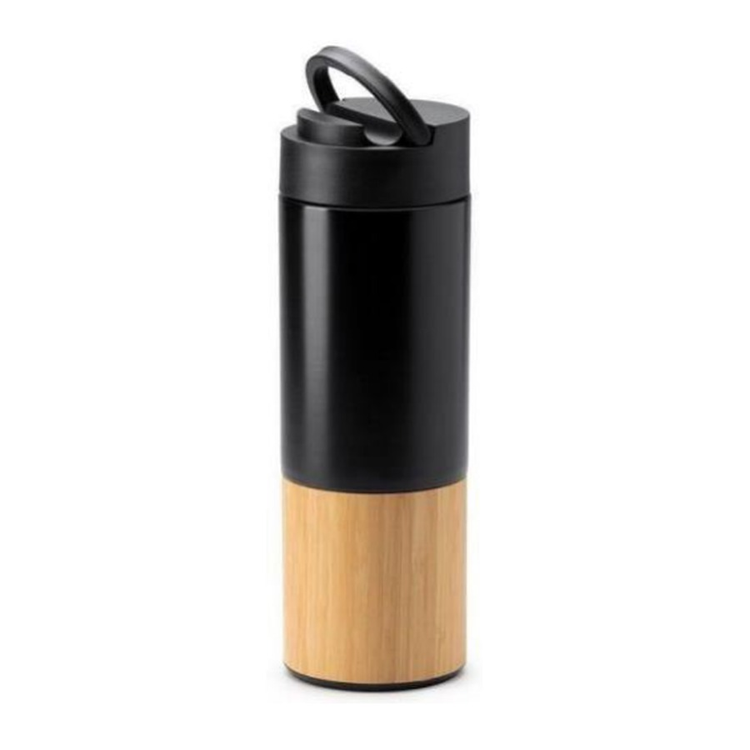  Stainless Steel With Bamboo Bottle  Capacity: 500 ml  Bamboo-finish bottle.  ₹ 245 + 18% GST
ITEM NO. 45  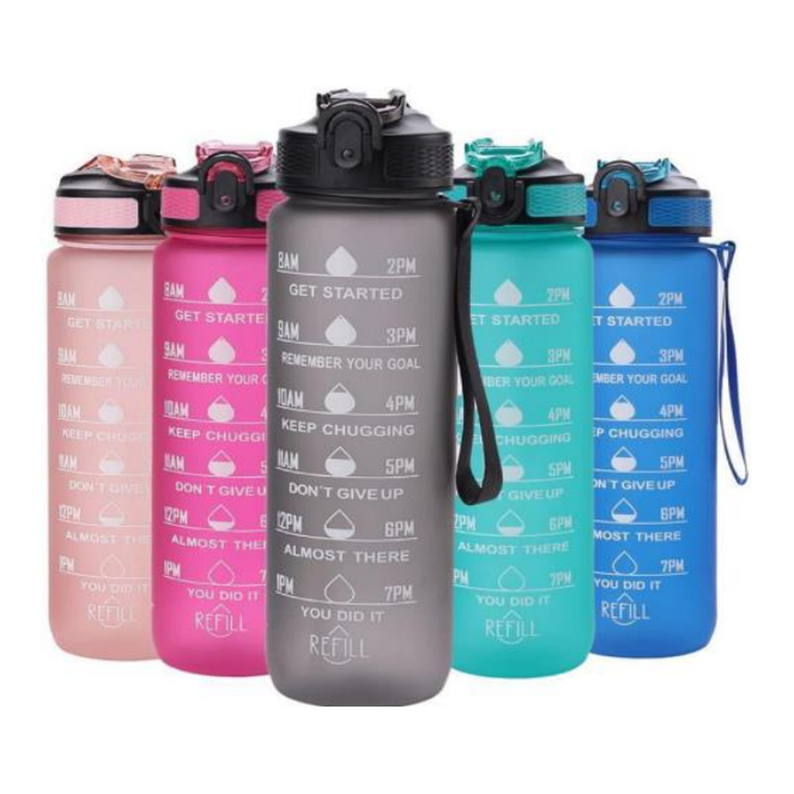  Motivational Time-marker Water Bottle  Capacity: 900 ml  Premium water bottle.  ₹ 120 + 18% GST |  | ITEM NO. 46  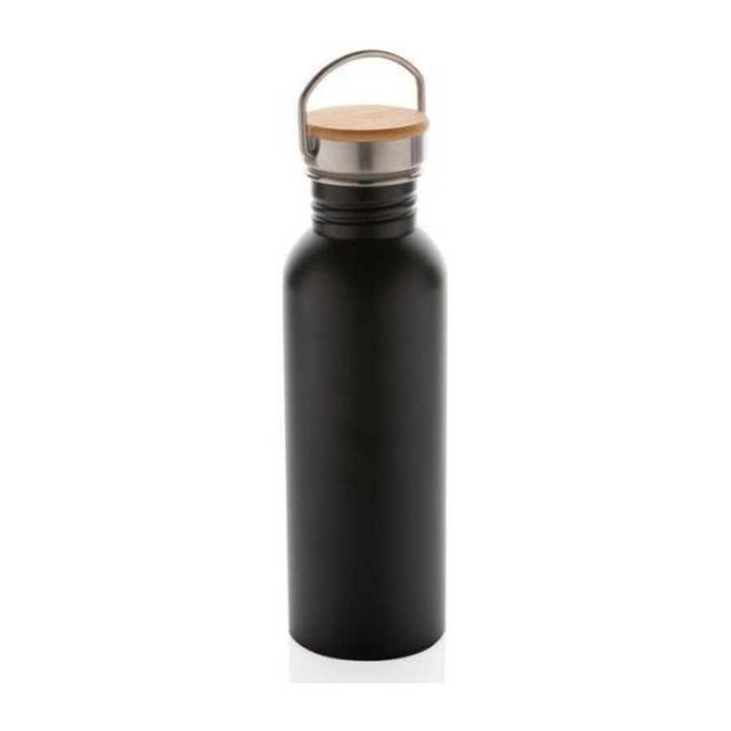  Bottle With Wooden Lid And Handle  Capacity: 750 ml  Premium water bottle with handle with wooden lid.  ₹ 185 + 18% GST
ITEM NO. 47  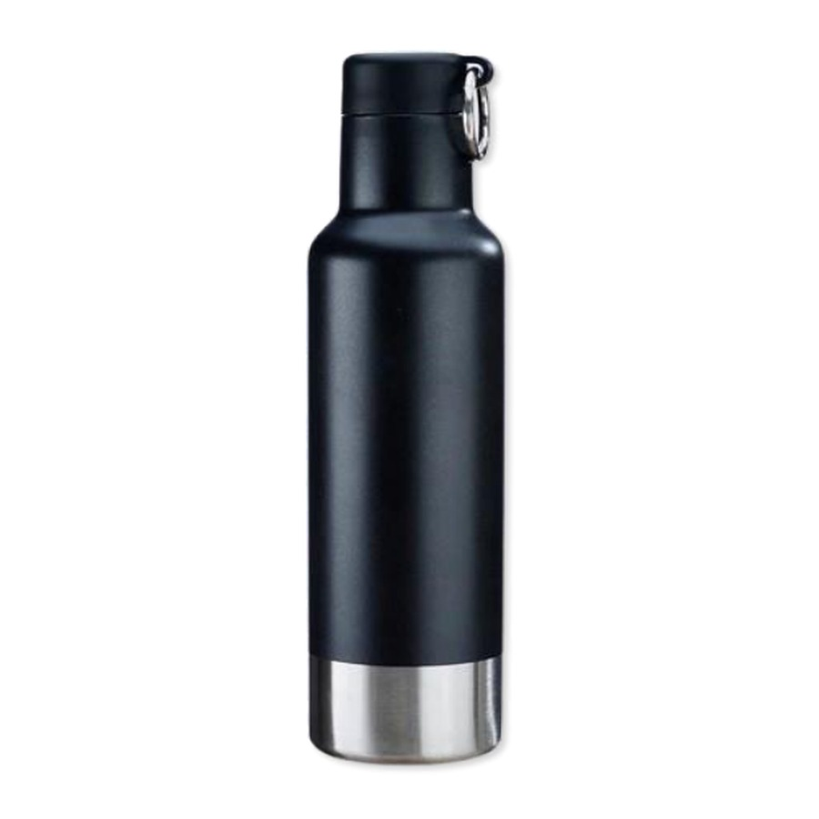  Single Wall Bottle  Capacity: 500 ml  Lightweight single-wall bottle.  ₹ 240 + 18% GST |  | ITEM NO. 48  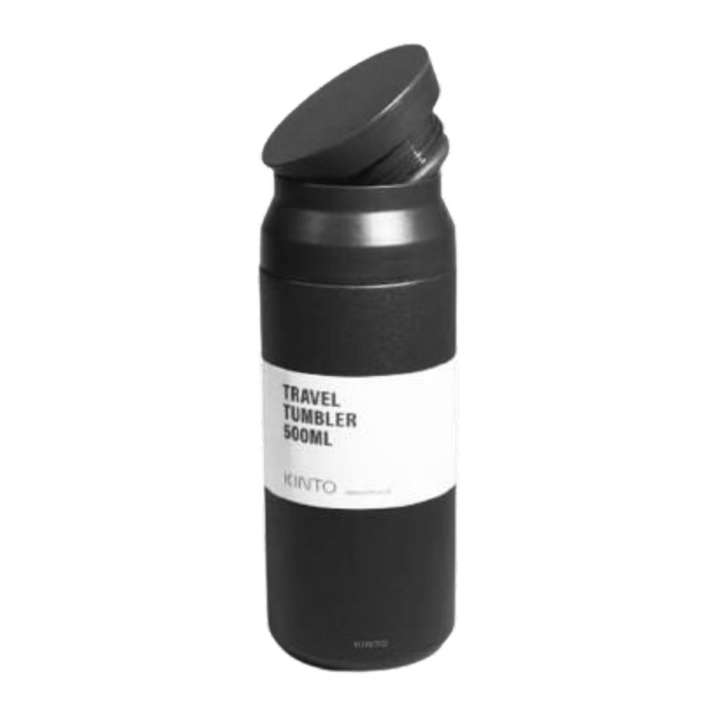  Single Wall Bottle  Capacity: 500 ml  Lightweight single-wall bottle.  ₹ 250 + 18% GST
ITEM NO. 49  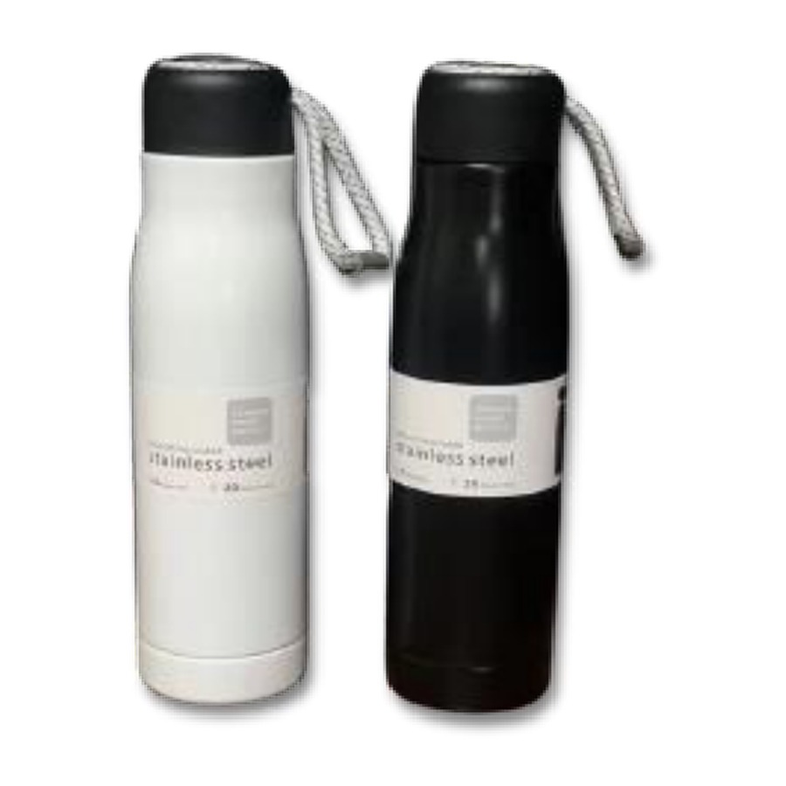  Rope Bottle  Capacity: 550 ml  Premium water bottle.  ₹ 170 + 18% GST |  | ITEM NO. 50  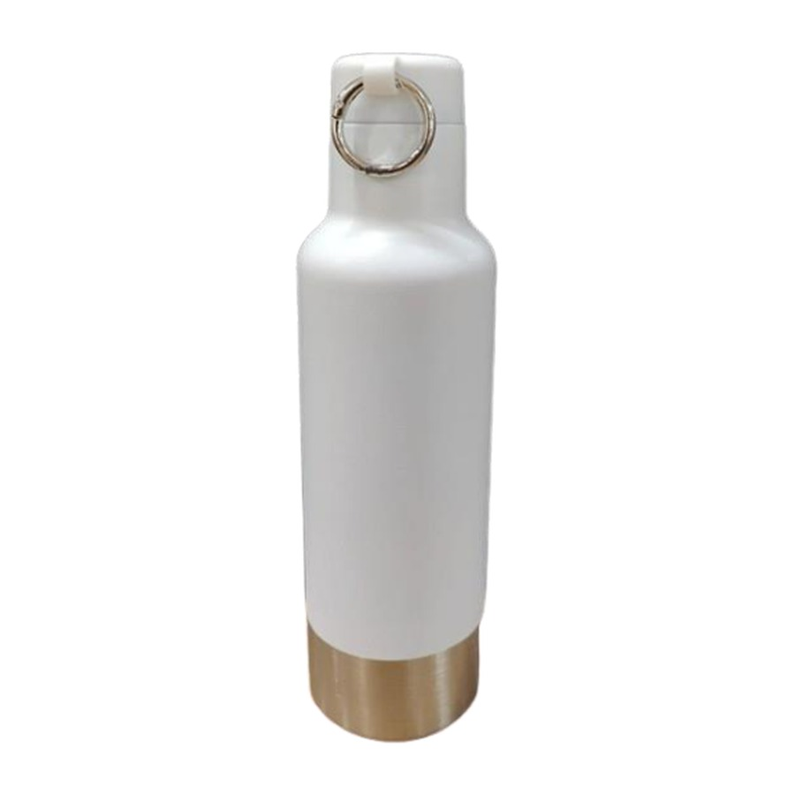  Stainless Steel Bottle With Carabiner Loop  Capacity: 500 ml  Stainless-steel bottle with carabiner clip.  ₹ 240 + 18% GST
ITEM NO. 51
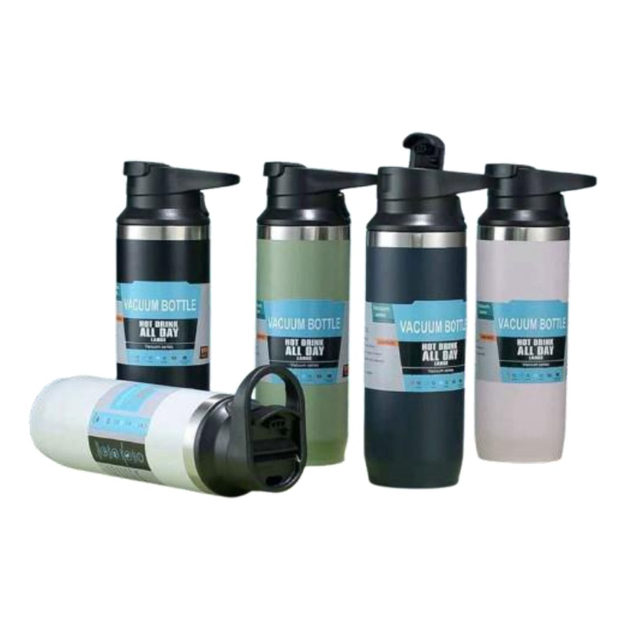
Loop Bottle
Capacity: 500 ml
Premium water bottle.

₹ 240 + 18% GST

Thank you
for considering Robust Gifting

All items available for custom branding.
Minimum order quantities and lead times on request.
Prices are exclusive of 18% GST. Valid 2026.

